***Name:*** *Kelila Karenza Kumala*

***NIM:*** *2602082080*

**LAB Project - JetFlix**

*\*Files are organized based on file type*

*\*HTML/CSS/JS was originally made on a 192o x 1080 px laptop screen*

*\*Figma frames are 1440 px in width*

*\*Frames are responsive at 980px, 768px, and 480px (all screen sizes below 320px are not considered because phones screen sizes are 320px-480px at average)*

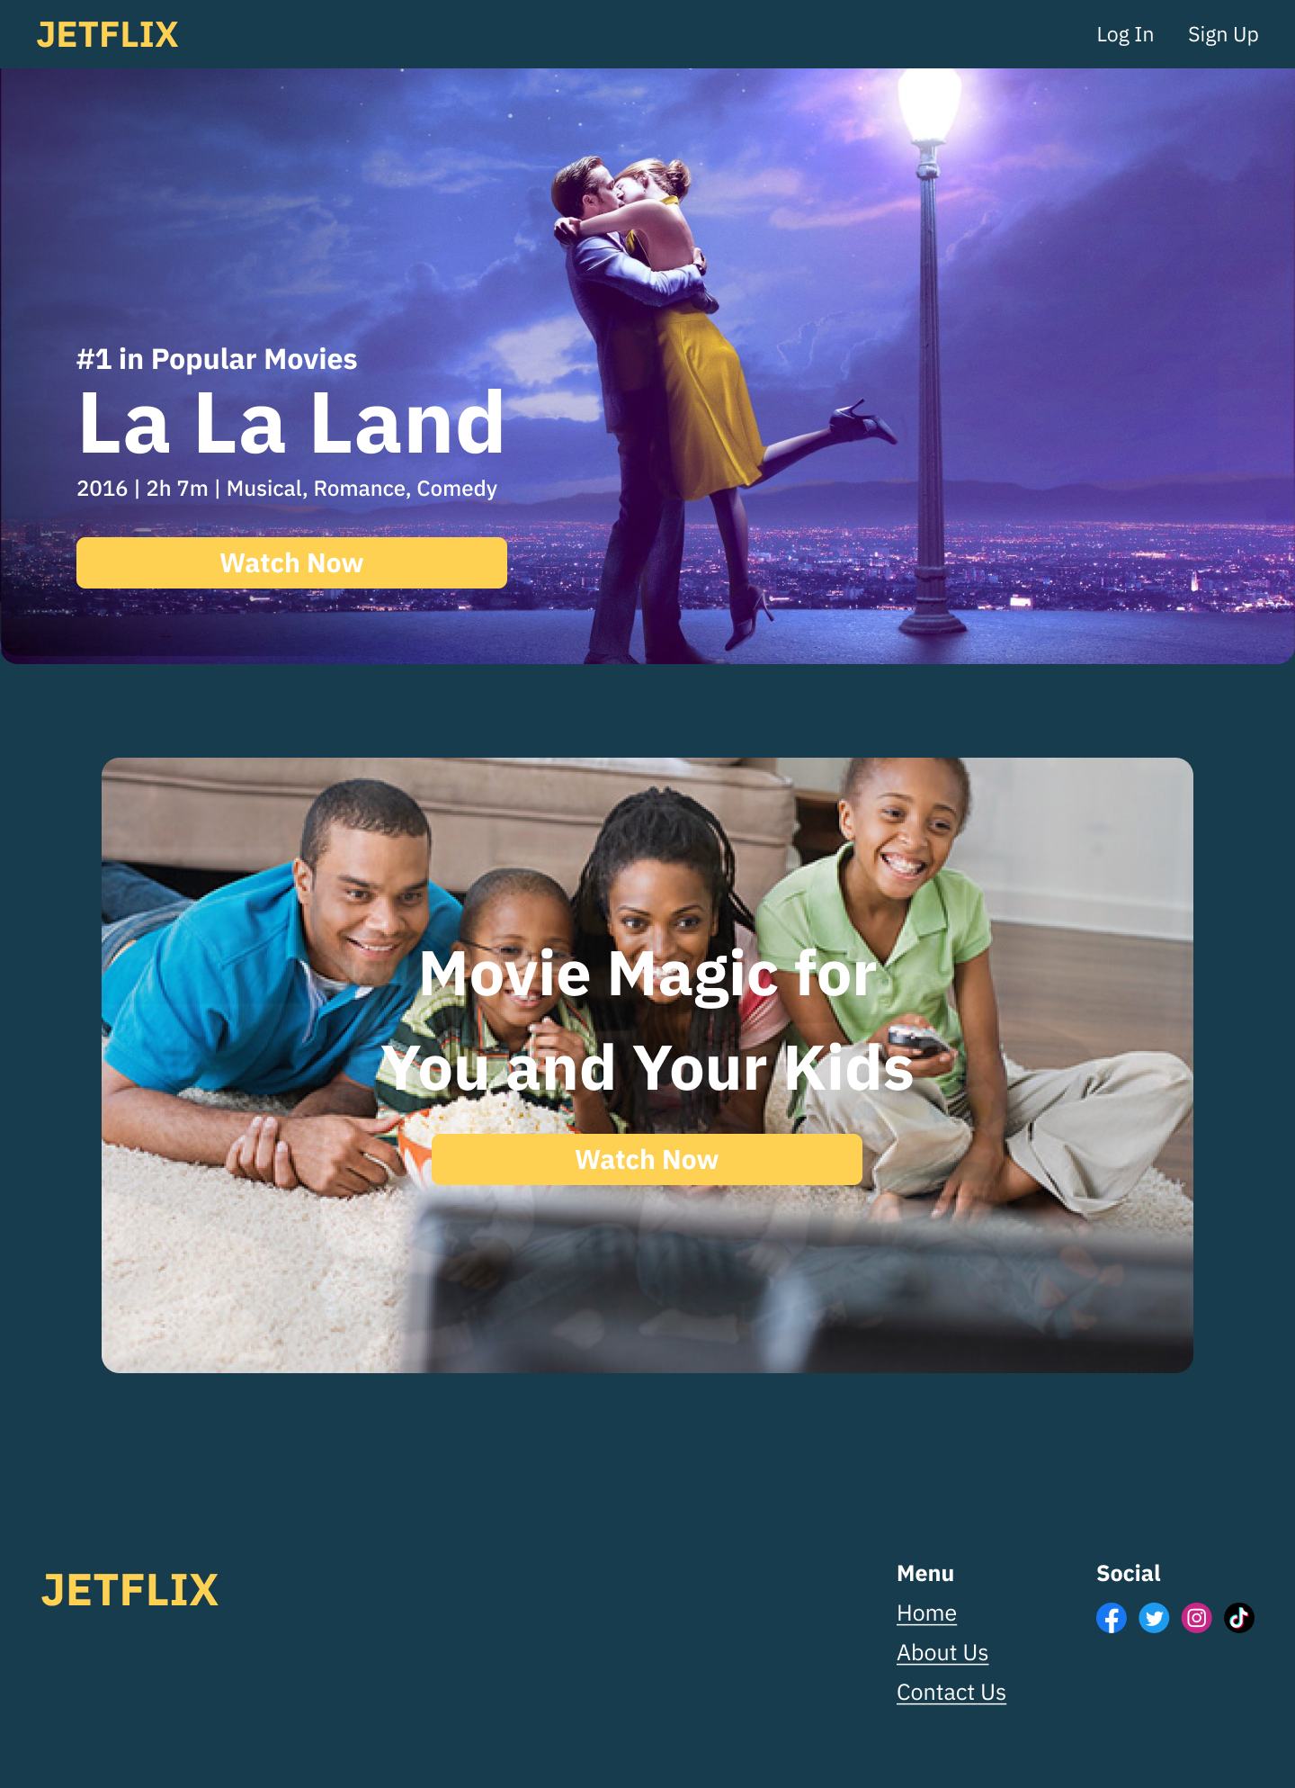

1. ***Landing page***

Users will open JETFLIX to the home/landing page. The landing page consists of:

* **Navbar** with headers
* **Top Movie** in JETFLIX
* **Kid’s profile**
* **Footer**

The landing page is only accessible if the user hasn’t logged in to JETFLIX. Users are unable to use JETFLIX’s features and browse movies if they haven’t logged in.

1. *Navbar*



Navbar has a JETFLIX logo that, when clicked, will redirect users to the landing page. On the right side, the Login button will bring users to the Login page and Sign Up button to the Sign Up page. The color of the Login and Sign Up buttons will change based on what page the user is on. Since this is the landing page, both buttons are inactive. Navbars are always on every page but they differ when the user logs in.

1. *Top Movie*



The top movie is a jumbotron that shows the poster of the #1 movie in JETFLIX’s Popular Movies List. The title, year of release, duration, and genre are shown along with a “Watch Now” button that will redirect users to the login page so they can start watching on JETFLIX.

1. *Kid’s Profile*



The kid’s profile is a simple image of a family watching with their kids with the tagline “Movie Magic for You and Your Kids” to show that JETFLIX is kid-friendly. Below that is a “Watch now” button that will redirect users to the login page.

1. *Footer*



The footer has JETFLIX’s logo which will redirect users to the landing page when clicked. On the right side, there’s the Menu section which has main features such as “Home”, “About Us”, and “Contact Us”. Next to are 4 social media platforms that JETFLIX have. The footer will be available on every page.

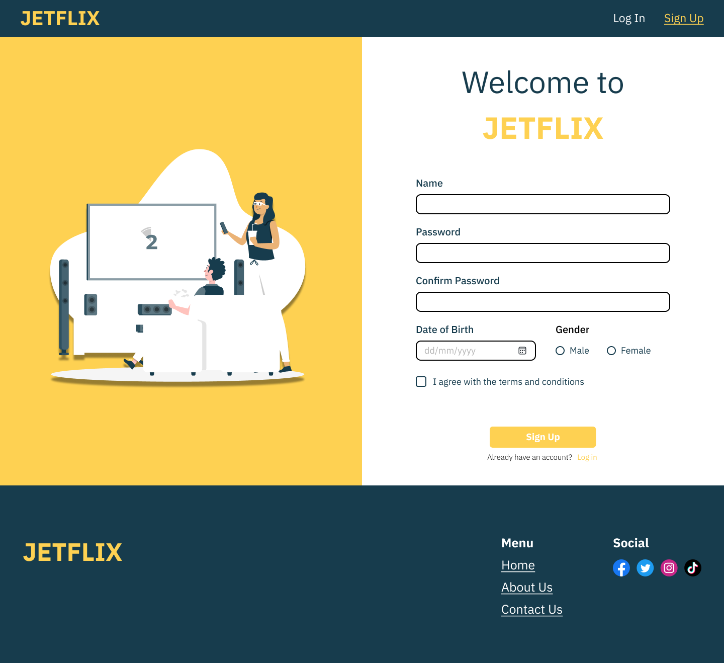

***2. Sign up page***

The sign up page consists of:

* Navbar
* Cover
* Forms
* Footer (same as before)

Users can access the sign up page from the landing page.

1. *Navbar*



The navbar is similar as before. However, since the user is on the sign up page, the Sign Up button is active.

1. *Cover*

The cover is a simple image that is eye-catching for the user once they open the sign up page.

1. *Forms*

The main part of the sign up page are the forms. To sign up, users must fill in their name, password, password confirmation, date of birth, gender, and agree to the terms and conditions. Below that is the sign up button to submit the form. If users already have an account, they can navigate the login page from the link below the login button.

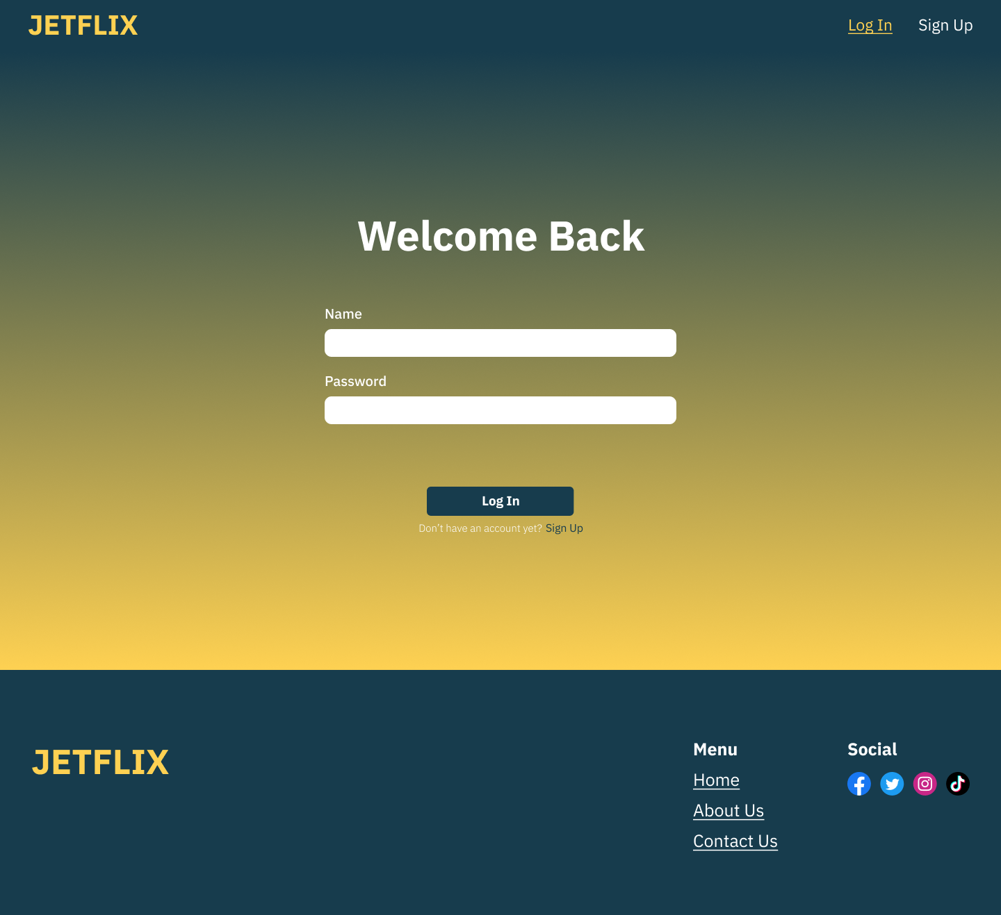

***3. Login Page***

The login page consists of:

* Navbar
* Form
* Footer (same as before)

Users must go through the login page first before being able to use JETFLIX’s features.

1. *Navbar*

The navbar is similar as before. However, since the user is in the login page, the login button is active.

1. *Form*



The login page only consists of 2 forms: name and password. Users must fill in both fields in order to login to JETFLIX. Below the forms is the login button and underneath that is a link to redirect users to the sign up page in case they don’t have an account yet.

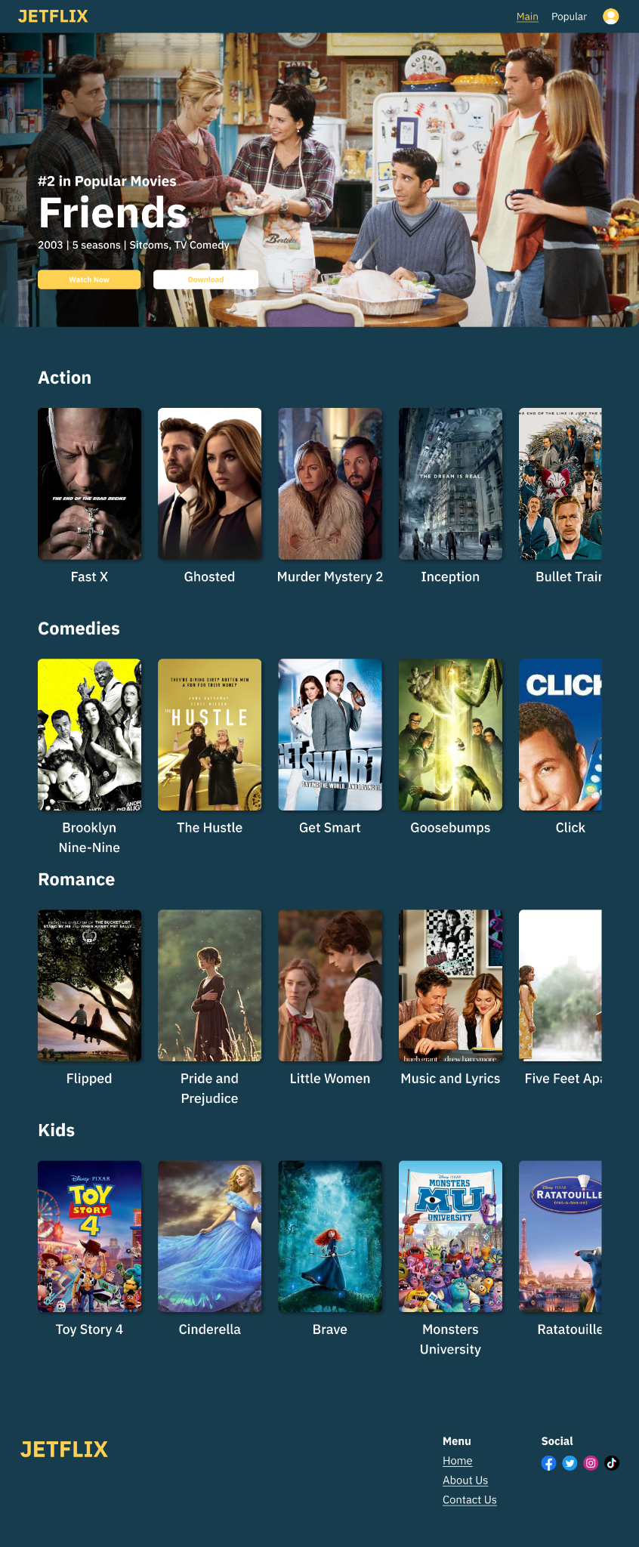

***4. Movie Page***

The movie page consists of:

* **Navbar**
* **Jumbotron**
* 4 movie **genre sections**
* 5 or more **movies** per genre
* **Footer**

The movie page is only accessible after users logged in to JETFLIX and is where users are redirected to upon logging in/signing up. This page now acts as the main page where all available movies can be seen.

1. *Navbar*

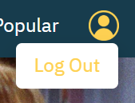

The navbar in the movie page is different from before because the user has already logged in. The JETFLIX logo will now redirect users to the movie page. On the right side, available pages on JETFLIX are now visible. There are main and popular pages and the color and design of the button will change depending on which page the user is currently on. Since the user is in the movie page (main), the Main button is active. Next to it is the user’s profile. On hover, a LogOut dropdown will appear for users to logout when they want to and this will redirect them to the landing page.

1. *Jumbotron*



The Jumbotron is a top movie in JETFLIX. It has the poster of the movie with the ranking, title, year of release, genre, and number of seasons if it’s a series. Below it are the “Watch Now” and “Download” buttons. The “Watch Now” button will redirect users to the movie detail page while the “Download” button will alert users that they have downloaded the movie.

1. *4 movie genre sections*

There are 4 movie genres: Action, Comedies, Romance, and Kids. All movies are categorized in this section. In each genre section, there are at least 5 movies in which posters and titles are written. Users can scroll through the genres to browse available movies. When on hover, the movie users are interested in will expand.

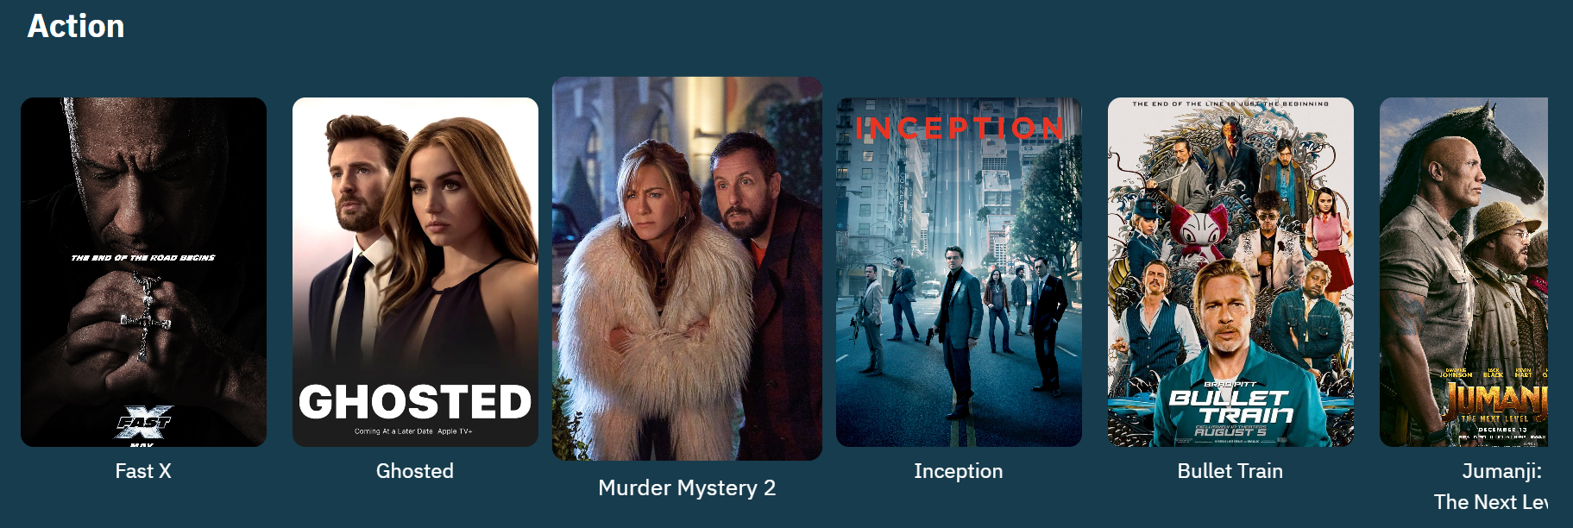

* poster image expands

1. *Footer*



The footer is the same as before.

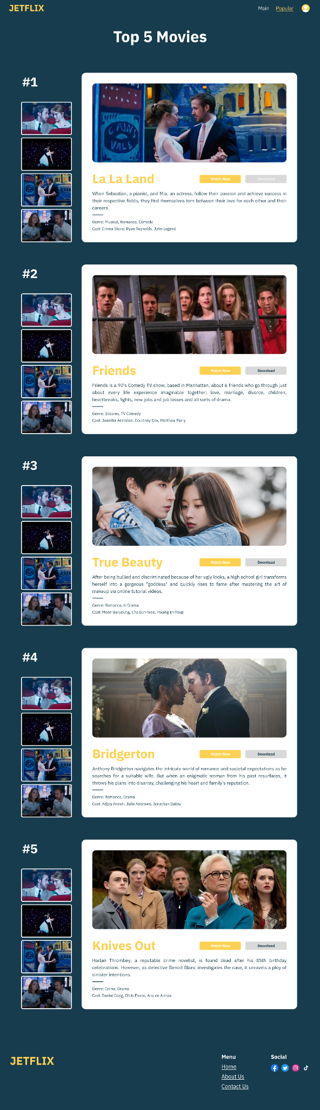

***5. New and Popular page***

The new and popular page consists of:

* Navbar
* Top 5 Movies in cards
* Slideshow images
* Footer (same as previous page)

This page shows the Top 5 movies that are popular at the moment in JETFLIX. This page can only be accessed when the user has logged in.

1. *Navbar*

The navbar is the same as the movies page. However, since the user is currently in the Popular page, the Popular button is active.

1. *Top 5 Movies card*



The main elements in the popular page are the top 5 movies in the form of a card. The card contains an image from the movie, title, synopsis, genre and cast. On the right are the “Watch Now” and “Download” buttons. Each movie is put in 1 card so there are 5 cards in total.

1. *Slideshow images*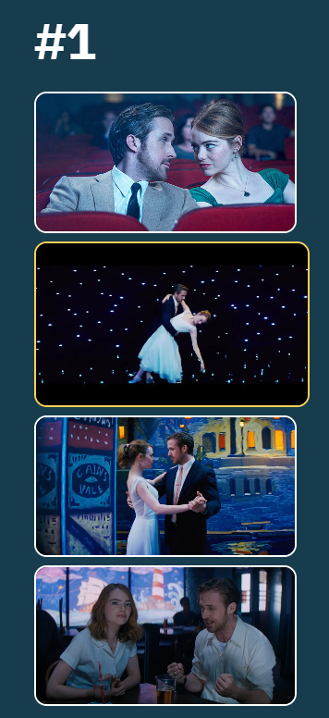

Beside the card are 4 other images that can be selected as a slideshow. When clicked, the image on the card will change accordingly. The slideshow expands on hover and a yellow border appears.

***6. Movie Detail page***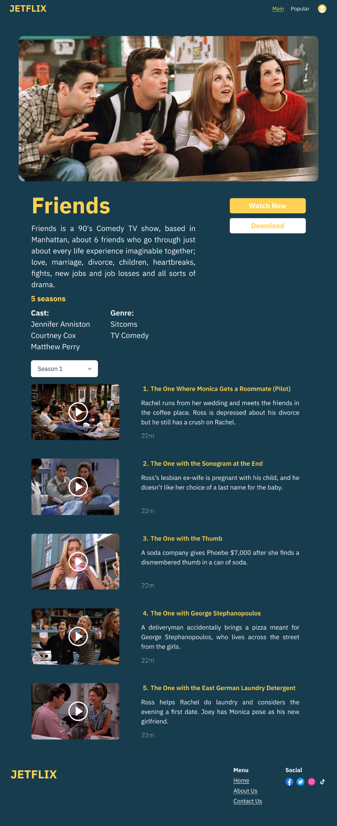

The movie detail page consists of:

* Navbar
* Jumbotron
* Movie Description
* Episodes
* Footer (same as before)

The movie detail page contains the details about the selected movie. In this prototype, only 1 movie can be accessed (Friends). Users can see what the movie/series is about and how many seasons are available.

1. Navbar

The navbar is similar as before. However, since the user is simply opening the detailed page of a certain movie, they are considered to still be in the main page. Therefore, the main button is active on the navbar.

1. Jumbotron

The jumbotron is an image of a scene from the movie/series selected that serves as the main component in the movie detail page.

1. Movie Description

The movie description section has the movie/series’ title, synopsis, number of seasons, cast, and genre. On the right are the “Watch Now” and “Download” buttons. This section gives users a brief idea of what the selected movie/series is about.

1. Episodes

On the top of the episodes, there is a dropdown button which allows users to select the season they would like to see. Underneath that are the episodes in that selected season. Users can see the episode title, brief synopsis, and episode duration. Each episode has an image of a scene from that episode.

***References:***

* Storyset by Freepik (plugin on figma)

<https://www.freepik.com/author/stories>

* Netflix as reference
* Code tutorials

<https://www.w3schools.com/>

* Color palette

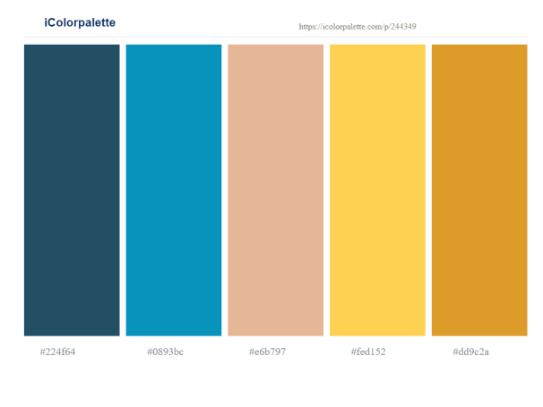

* Images in design are all taken from google